**CREATION OF INSTANCE IN AWS USING TERRAFORM**

We are creating an instance with the name of example in ap-south-1 region in default vpc.

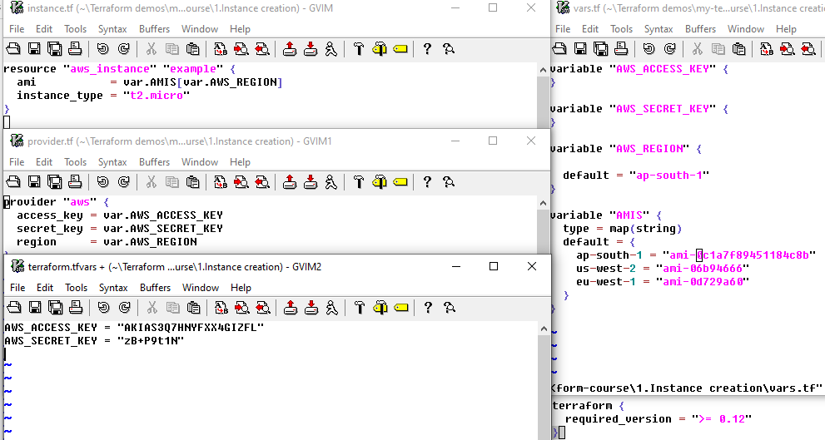

Create a directory where you create all your project files

mkdir myproject

cd myproject

Following are the terraform files which is used to create an instance:-

**Instance.tf**

In this file we give the details of our instance like name of the instance is example,ami and instance type.

**Provider.tf**

In this file we mention Provider,access key ,secret key and region in our case provider is aws,accesskey and secret key is present in terraform.tfvars file .

**Terraform.tfvars**

To make the access key and secret key secure we put both the key in this file and while do git push we make this file as git ignore

**Vars.tf**

We mention all the variables in this file like AWS_SECRET_KEY,AWS_ACCESS_KEY,AWS_REGION,AWS_AMIS .

As we created all the above files then we have to run the command

**1.Terraform plan**

After completion of terraform plan command you can see .terraform directory will get created in myproject directory.

**2.Terraform apply**

After completion of this command terraform.tfstate file get created in the directory (myproject)